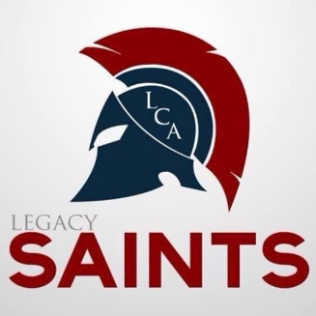
Legacy Christian Academy
5933 Valley Pike, Stephens City, VA 22655

LCA Student Shadow Program
Come be a “Saint” for the day! LCA would like to encourage you to have your student spend a day with us. This could be the most important part of enrolling in Legacy.
Shadowing: Shadowing with a student at Legacy Christian will allow your student to meet some of the students, attend classes, participate in any activities for the day, and much more. Your student will be paired with a LCA student to guide them through the day and answer any questions they may have.
Options: One option available is for your child to spend half of the day in the grade he or she will be entering and half of the day in his or her current grade.
The other option is to spend the entire day in one grade (either the grade they would be going to next year or with those in the current grade that they will be classmates with). Shadow days may be scheduled any day by request, except for days when special events would make it not ideal to shadow.
Arrival and Dismissal: On the scheduled shadow day, your child will check in at the school office at 8:00 AM to meet with our Admissions Director, Mrs. Poole. Mrs. Poole will then take your student and set them up with their buddy for the day. Parents should leave emergency numbers and any important information for the day, such as information on allergies. Parents can feel free to either park and come in with the student or they come through the drop off line with the other parents. Then, at the end of the day, your child may be picked up at 3:15. Parents can just pull through the parent pick up line and we will help your student to get out to you.

Dress Code: LCA students follow a specific dress code. Your child may choose to wear a similar outfit or wear appropriate jeans and a t-shirt. Our boys wear Khakis, navy, or black pants or knee length cargo shorts and a polo. Our girls wear Khaki, navy, grey or black pants or knee length cargo shorts and a polo or a Khaki, navy, grey, or black (to Top of the knee) knee length dress or a skirt and a hoodie.
Lunch: You may purchase a meal from the cafeteria for $6.00. You would need to tell Mrs. Poole or the receptionist when you drop off and you would pay the money to the receptionist. Your student may also choose to pack their lunch. Drinks and snacks are also available in the cafeteria for a minimal cost.
Cell Phones: Legacy does not allow student to have their cell phones during the school day. They are a distraction to education. Your student can either leave their phone with their parent or they can turn it in to Mrs. Poole and get it back at dismissal. Should the student need to call the parent, they will be able to do so by coming to the office.
To schedule a shadow day, please log on to www.legacychristian-academy.com and click on “Admissions”, email Admissions@legacychristianacademy.com, or call the Admissions office at 540-877-7336.
We look forward to spending the day with you!

