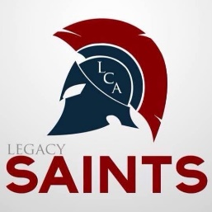
Student Athletic Grooming and Hygiene Policy.

This includes student enrolled at Legacy Christian Academy, Home School students playing on Legacy teams, and students from other schools participating on Legacy teams.

- Christian modesty in dress is important to the image being promoted by LCA.
- The coaches will determine the appropriate dress standard for students traveling to games. The policy will be determined in consideration of the distance that will be travelled on road trips. Modesty will always be distinctive in any attire that is allowed.
- No gothic or extreme jewelry or makeup is allowed on our athletes. No black nail polish shall be worn. Extreme styles not covered in our documentation will be defined by the Athletic Director as to their appropriateness.
- Faddish hair styles on boys or girls must be approved by the Athletic Director. Hair colors should be in the natural category. Faddish colors like pink, green, extreme red, purple, violet, indigo, blue, etc. are not allowed. Any haircut styles showing baldness or strange styling are not allowed. The athletic director has the right to determine if nay coloring, combinations of colorings, or cutting styles not mentioned above are allowable or not. Any temporary hair designs for the purpose of unity for a cause are to be approved at the discretion of the Athletic Director.
- Good hygiene practices are to be practiced.
- Clothing should be neat, clean, not frayed, or have holes in the garments.
- Girls are not to wear clothes designed for boys and boys are not to wear clothes designed for girls.
- No body piercings jewelry other than earrings are allowed other than pierced earrings on girls only. The girl’s earrings need to be modest in size. Students should wear as little jewelry as possible for safety purposes. During athletic competition no jewelry can be worn.
- No visible tattoos should be observable to public view. Temporary tattoos for team spirit purposed must be approved by the Athletic Director.
- Fake fingernails cannot be worn during athletic competition.

Athlete’s Signature: ________________________________________________________
Parent/Guardian Signature: _________________________________________________

